# **Power BI Project Documentation**

## **1. Project Overview**

### **1.1 Project Title**

Plato Pizza Sales Dashboard.

### **1.2 Objective**

### To help the restaurant Plato Pizza improve its operations and performance using the dataset collected in 2015.

### **1.3 Scope**

#### **Datasets Used:**

#### The project analyzes a **year's worth of sales (2015)** from a fictitious pizza place, leveraging four tables:

#### **Order details (Fact Table)**

Contains 48,621 rows and 4 columns: order details id, order id , pizza id , quantity.

**Orders (Dimension Table)**

Contains 21,350 rows and 3 columns :order id , date ,time.

**Pizza types (Sub - dimension Table of Pizza)** – Contains 33 rows and 4 columns: pizza type id, name ,category ,ingredients

**Pizzas (Dimension Table)** – Contains 97 rows and 4 columns: pizza id, pizza type id, size , price

#### **Key Metrics:**

* **Total Revenue:** Overall sales performance **.**
* **Total Orders:** Number of orders placed.
* **Total Pizzas Sold**: Total quantity of pizzas sold.

#### **Visualizations:**

* **Total Sales Overview**: A summary dashboard with revenue, order count, and pizzas sold.
* **Time-Based Sales Trends**: Interactive charts showing sales by **month, day, and hour.**
* **Best & Worst Selling Pizzas: Bar charts and tables** ranking pizzas by revenue and quantity.
* **Pizza Category & Size Analysis: Pie charts and bar graphs** showcasing revenue distribution.
* **Customer Behavior Insights: Stacked bar charts** comparing different order group sizes.
* **Seat Occupancy Impact: Heatmaps or scatter plots** showing how seat usage affects sales patterns.

#### **1.4 Timeline**

Provide an estimated timeline for different phases of the project, such as data collection, cleaning, modeling, visualization, and final review.

|  |  |  |
| --- | --- | --- |
| **Phase** | **Description** | **Estimated Duration** |
| Data Collection | Gathering relevant datasets | 1 day |
| Data Cleaning | Handling missing values, removing duplicates | half day |
| Data Modeling | Defining relationships, creating measures | half day |
| Visualization | Designing dashboard and visual elements | 3 days |
| Final Review | Testing and refining dashboard | 2 days |

## **2. Data Collection & Preparation**

### **2.1 Data Sources**

The datasets are in the form of csv file.

### **2.2 Data Cleaning & Transformation**

Before conducting the analysis, I performed several **preprocessing steps** in **Power Query** to ensure data quality and consistency .Such as:

### **Handling Missing Values**

* **Checked for Null Values** in each table by taking the column profiling.

### **Removing Duplicates**

* **Checked for duplicate rows** in each table using Remove Duplicates in Power Query.
* **Duplicates were removed** from:
  + orders (based on order_id)
  + order_details (based on order_details_id)
  + pizzas (based on pizza_id)
  + pizza_types (based on pizza_type_id)

### **Data Type Transformations**

* Converted **date and time columns** (orders.date and orders.time) into **datetime format.**
* Transformed **price columns** (pizzas.price) into **decimal format**.
* Converted **order quantity (**order_details.quantity**)** into **whole number format** for analysis.
* Standardized text columns (pizza_types.name, pizza_types.category) by **removing extra spaces**.
* Extracted date components:Year, Month, Day, Weekday (for trend analysis).

### **2.3 Data Model**

Developed a Snowflake schema for creating relationship and **established relationships** between tables using **one-to-many joins**

* + orders - order_details (order_id)
  + pizzas - order_details (pizza_id)
  + pizza_types - pizzas (pizza_type_id)

## **3. Dashboard Development**

### **3.1 Mockup Designs**

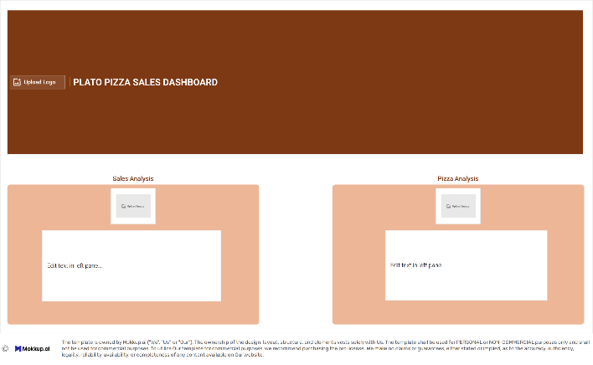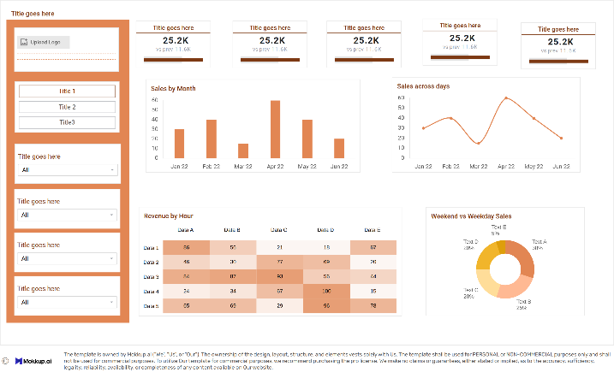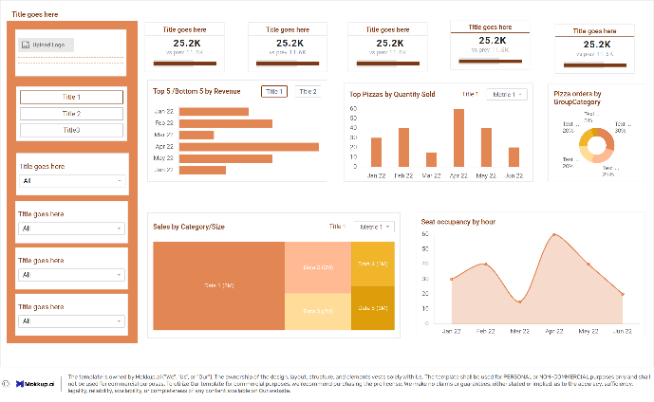

### **3.2 Key Visualizations**

## **Key Performance Indicators (KPIs)**

**Purpose:** Summarize overall business performance.  
 **Metrics:**

* **Total Revenue**
* **Total Orders**
* **Total Pizzas Sold**
* **Average Daily Pizza Sold**
* **Average Pizza per Order**

**Visualization Type:** KPI Cards with dynamic comparison to previous periods.

## **Interactive Filters & Slicers**

**Purpose:** Enable dynamic data exploration.

**Visuals Used:**

* **Date Range Picker** → Filter by specific months or days.
* **Dropdown Slicers** → Filter by pizza category, size, and type.

## **Sales Trends Over Time**

**Purpose:** Analyze revenue and order volume across different time frames.  
**Visuals Used:**

* **Bar Chart** → Monthly Revenue Trends
* **Line Chart** → Day wise Revenue Trends
* **Heat Map Chart** → Hourly Sales Distribution
* **Donut**  **Chart** → Weekend and Weekdays Sales Distribution

## **Pizzas Performance**

**Purpose:** Determine the best and least popular pizzas based on revenue and quantity sold.  
**Visuals Used:**

* **Horizontal Bar Chart** → Top 5 pizzas by revenue.
* **Horizontal Bar Chart** → Bottom 5 pizzas by Revenue.
* **Vertical Bar Chart** → Top 10 pizzas by Quantity Sold.
* **Donut Chart** → Comparing the proportion of 2 person order and 3+ person order.
* **Tree map** → Pizza Category, Size and Sales.
* **Area Chart** → Seat occupancy by Hours.

### **Measures and Calculations**

Describe any DAX measures, calculated columns, and key performance indicators (KPIs) created

* **Total Revenue :**Computes total sales by multiplying the quantity of pizzas sold by their respective prices
* **Total Orders :**Provides an exact count of unique orders.
* **Total Pizzas Sold:Counts the total number of pizzas sold across all orders**
* Average Daily Pizza Sold : Calculates the total number of pizzas sold per day on average.
* Average Pizza Per Order : Measures how many pizzas are typically included in a single order.

### Hour **:** Breaks down total pizza sales by hour of the day.

### Group Category (2-Person vs. 3+ Person Orders): Categorizes orders based on the number of pizzas.

### Seat Occupancy : The number of seats occupied at tables.

### Weekend and Weekday Sales : Compares pizza sales on weekends vs. weekdays.

### **3.4 Filters and Slicers**

**Month Selector:** Allows business owners to compare seasonal trends

**Day of the Week Filter:** Allows filtering by specific days (e.g., comparing sales on Fridays vs. Mondays).

Pizza Category Filter**:** Users can filter sales based on pizza types (e.g., Veg, Non-Veg, Classic, Specialty).

Pizza Size Filter**:** Enables selection of Small, Medium, Large, or Extra-Large pizzas to analyze their popularity.

## **4. Insights & Findings**

* Identify peak sales months and days.
* Understand customer ordering behavior by time of day.
* When is the restaurant busiest?
* Understand customer ordering behavior during weekends and weekdays.
* Which pizzas contribute most to revenue?
* Do customers prefer large pizzas over small ones?
* Which pizza categories are most profitable?
* Are there underperforming items that should be replaced or promoted?
* Do customers typically order in small or large groups?
* Which order sizes should be promoted with deals?
* How well they utilizing seating capacity?

**Sales Performance Overview**

* Total Sales**:** $818K in revenue from 21K orders and 50K pizzas sold.
* Business Impact**:** Helps in understanding overall revenue trends and evaluating performance against targets.

**Peak Sales Hours & Time-Based Trends**

* Highest Sales**:** Evening hours (6 PM - 9 PM) show peak demand.
* Lowest Sales**:** Early mornings and late nights have minimal orders.
* Business Impact**:** Assists in optimizing staffing, promotions, and inventory management.

**Top & Least Selling Pizzas**

* Best-Selling**:** Classic Pepperoni and BBQ Chicken are customer favorites.
* Lowest Sales**:** Certain specialty pizzas have low demand.
* Business Impact**:** Helps in refining the menu by promoting best-sellers and re-evaluating underperforming items.

**Customer Order Behavior**

* Small Orders (1-2 Pizzas): Make up a large share, indicating a high number of individual or couple orders.
* Group Orders (3+ Pizzas): Significant volume, suggesting opportunities for combo deals and group discounts.
* Business Impact**:** Helps in designing better meal bundles and pricing strategies.

**Seat Occupancy & Sales Impact**

* High Sales Days**:** Peak occupancy correlates with higher sales, especially on weekends.
* Low Occupancy Periods**:** Suggests opportunities for lunchtime discounts or weekday promotions.
* Business Impact: Helps optimize table management and promotional timing.

**Weekend vs. Weekday Sales**

* Weekend Sales**:** Higher than weekdays, driven by family and group dining.
* Weekday Sales**:** Lower, but lunch hours show steady demand.
* Business Impact**:** Encourages targeted promotions for weekdays to boost traffic.

**How These Insights Help in Decision-Making:**

* Adjust menu offerings based on best-sellers and underperforming pizzas.
* Optimize staffing and inventory based on peak sales hours and customer trends.
* Introduce promotional campaigns (e.g., lunch specials, group discounts) to drive sales.
* Improve seating arrangements and restaurant layout to maximize occupancy efficiency.

## **5. Challenges & Limitations**

* Faced difficulties in selecting between **calculated columns** and **DAX measures**
* Issues with **DIVIDE() function** in handling zero values, leading errors in calculations like seat occupancy.
* Assumptions in Seat Occupancy & Order Grouping, there is no direct data.
* Group order classification (2-person vs. 3+ person) is based on assumed pizzaconsumption per person, which may not always be accurate.

## **6. Future Enhancements**

* Integrating customer details (age, location, preferences) for deeper insights into purchasing behavior.
* Adding campaign data to measure the impact of discounts, special offers, and advertisements on sales.
* Supplier & Inventory Data**:** Tracking ingredient availability and cost trends to optimize pricing and inventory management.
* Comparative Trend Analysis**:** Adding year-over-year sales trends (if historical data is available).

## **7. Conclusion**

This project enables Plato Pizza to make informed, data-driven decisions that improve profitability, optimize operations, and enhance customer satisfaction. By leveraging Power BI, the dashboard provides a **clear, visual representation** of key business metrics, empowering stakeholders to take proactive actions.

## **8. Appendix (If Required)**

I referenced Maven Analytics Challenges for guidance during this project.